Aim:

To run and implement Session handling in servlet.

Program:

1.session.html

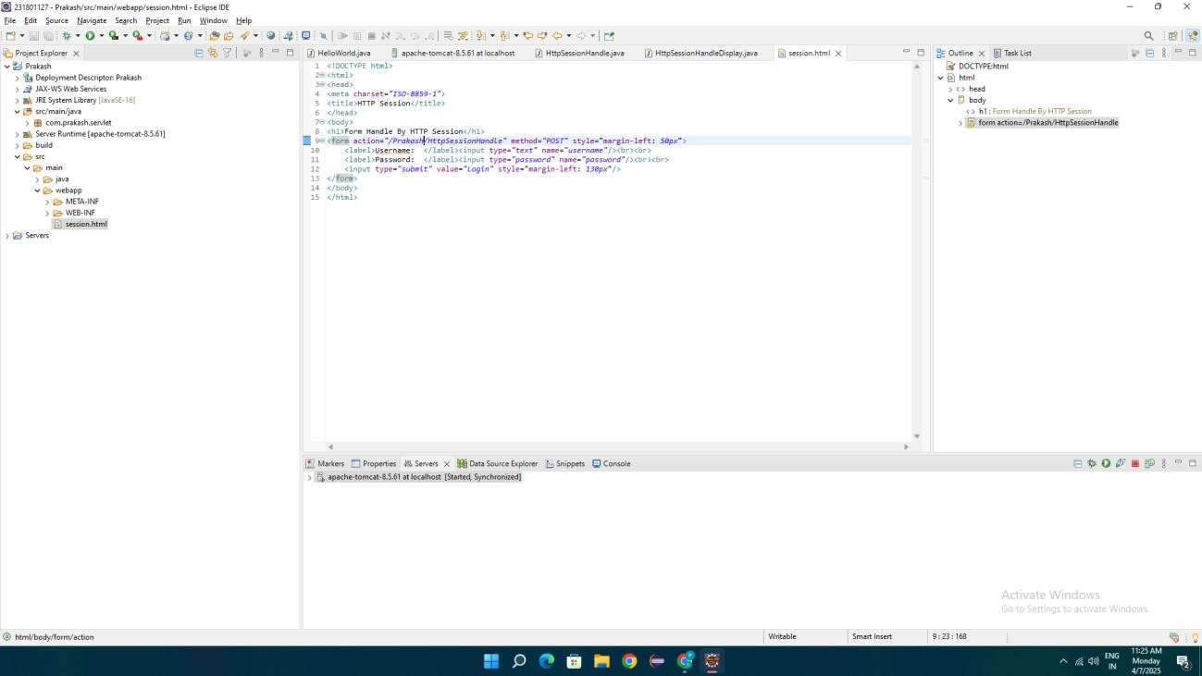

1. HttpSessionHandle

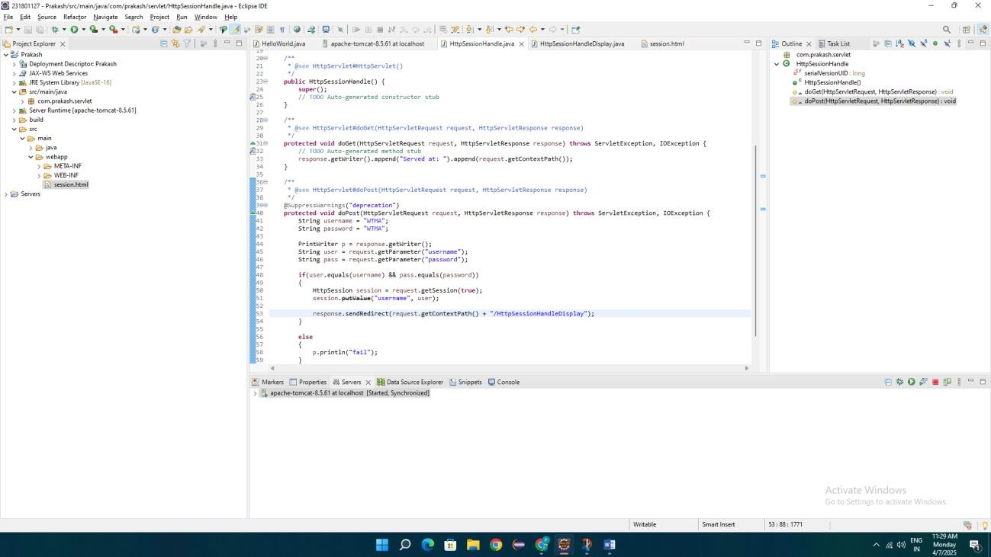

1. HttpSessionHandleDisplay

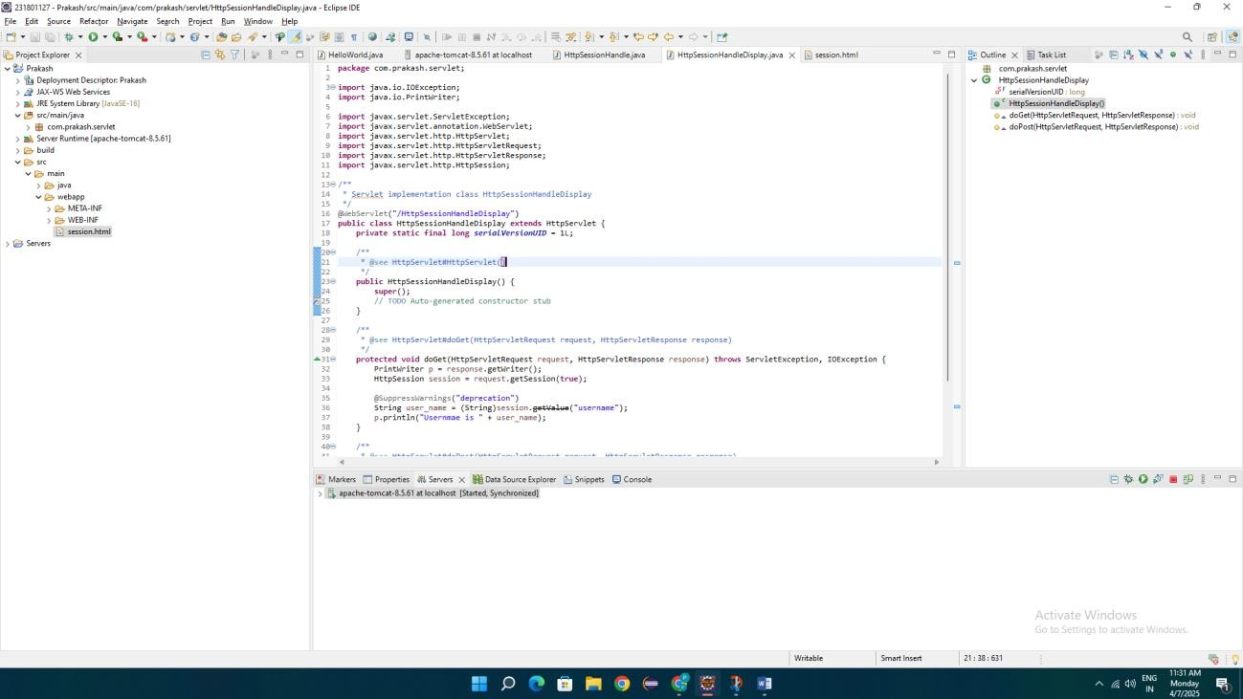

OUTPUT:

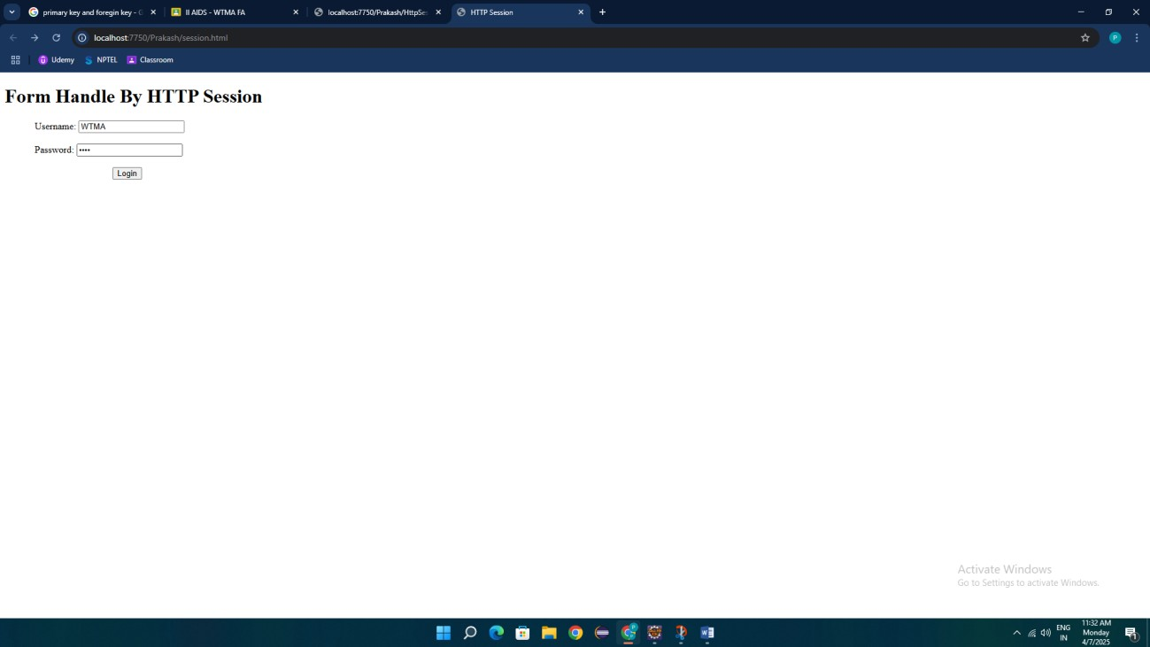

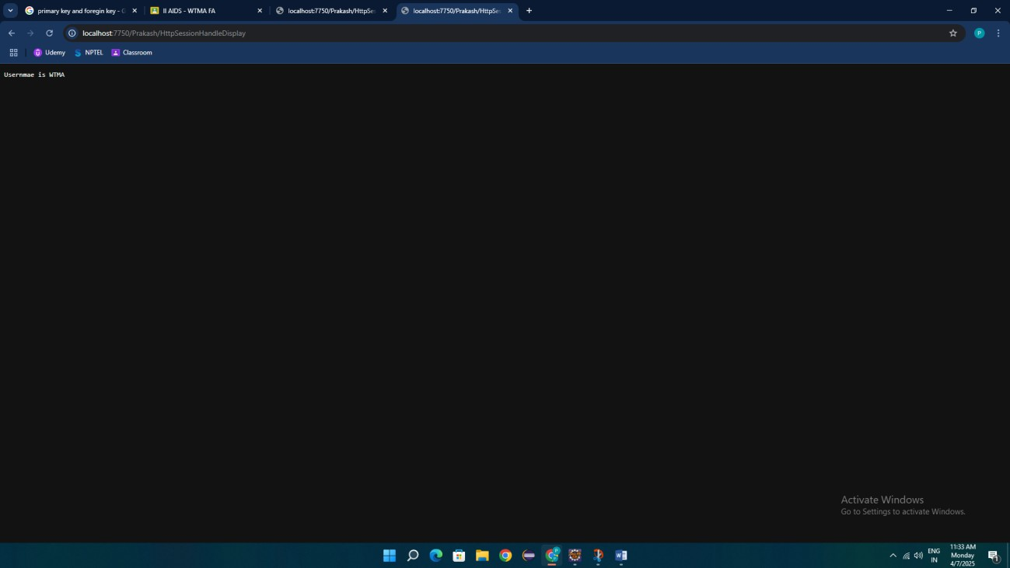

Program:

a) index.html

<!DOCTYPE html>

<html>

<head>

<meta charset=*"ISO-8859-1"*>

<title>Insert title here</title>

</head>

<body>

<h1>Form Handle By HTTP Session</h1>

<form action=*"/prakash/HttpSessionHandle"* method=*"POST"* style="margin-left: *50px*">

<label>Username: </label><input type=*"text"* name=*"username"*/><br><br>

<label>Password: </label><input type=*"password"* name=*"password"*/><br><br>

<input type=*"submit"* value=*"Login"* style="margin-left: *130px*"/>

</form>

</body>

</html>

b) HttpSessionHandle.java

**package** com.prakash.servlet;

**import** java.io.IOException;

**import** java.io.PrintWriter;

**import** javax.servlet.ServletException;

**import** javax.servlet.annotation.WebServlet;

**import** javax.servlet.http.HttpServlet;

**import** javax.servlet.http.HttpServletRequest;

**import** javax.servlet.http.HttpServletResponse;

**import** javax.servlet.http.HttpSession;

/**

* Servlet implementation class HttpSessionHandle

*/

@WebServlet("/HttpSessionHandle")

**public** **class** HttpSessionHandle **extends** HttpServlet {

**private** **static** **final** **long** ***serialVersionUID*** = 1L;

/**

* **@see** HttpServlet#HttpServlet()

*/

**public** HttpSessionHandle() {

**super**();

// **TODO** Auto-generated constructor stub

}

/**

* **@see** HttpServlet#doGet(HttpServletRequest request, HttpServletResponse response)

*/

**protected** **void** doGet(HttpServletRequest request, HttpServletResponse response) **throws** ServletException, IOException {

// **TODO** Auto-generated method stub

response.getWriter().append("Served at: ").append(request.getContextPath());

}

/**

* **@see** HttpServlet#doPost(HttpServletRequest request, HttpServletResponse response)

*/

**protected** **void** doPost(HttpServletRequest request, HttpServletResponse response) **throws** ServletException, IOException {

String username = "WTMA";

String password = "WTMA";

PrintWriter p = response.getWriter();

String user = request.getParameter("username");

String pass = request.getParameter("password");

**if**(user.equals(username) && pass.equals(password))

{

HttpSession session = request.getSession(**true**);

session.putValue("username", user);

response.sendRedirect(request.getContextPath() + "/HttpSessionHandleDisplay");

}

**else**

{

p.println("fail");

}

}

}

C) HttpSessionHandleDisplay.java

**package** com.prakash.servlet;

**import** java.io.IOException;

**import** java.io.PrintWriter;

**import** javax.servlet.ServletException;

**import** javax.servlet.annotation.WebServlet;

**import** javax.servlet.http.HttpServlet;

**import** javax.servlet.http.HttpServletRequest;

**import** javax.servlet.http.HttpServletResponse;

**import** javax.servlet.http.HttpSession;

/**

* Servlet implementation class HttpSessionHandleDisplay

*/

@WebServlet("/HttpSessionHandleDisplay")

**public** **class** HttpSessionHandleDisplay **extends** HttpServlet {

**private** **static** **final** **long** ***serialVersionUID*** = 1L;

/**

* **@see** HttpServlet#HttpServlet()

*/

**public** HttpSessionHandleDisplay() {

**super**();

// **TODO** Auto-generated constructor stub

}

/**

* **@see** HttpServlet#doGet(HttpServletRequest request, HttpServletResponse response)

*/

**protected** **void** doGet(HttpServletRequest request, HttpServletResponse response) **throws** ServletException, IOException {

PrintWriter p = response.getWriter();

HttpSession session = request.getSession(**true**);

@SuppressWarnings("deprecation")

String user_name = (String)session.getValue("username");

p.println("Usernmae is " + user_name);

}

/**

* **@see** HttpServlet#doPost(HttpServletRequest request, HttpServletResponse response)

*/

**protected** **void** doPost(HttpServletRequest request, HttpServletResponse response) **throws** ServletException, IOException {

// **TODO** Auto-generated method stub

doGet(request, response);

}

}

Result:

Thus the program to Session handling is implemented successfully.